**VPC-02**

1. **Create one VPC, with 1 public subnet and 1 private subnet.**

Created one VPC with CIDR range- 198.168.0.0/24

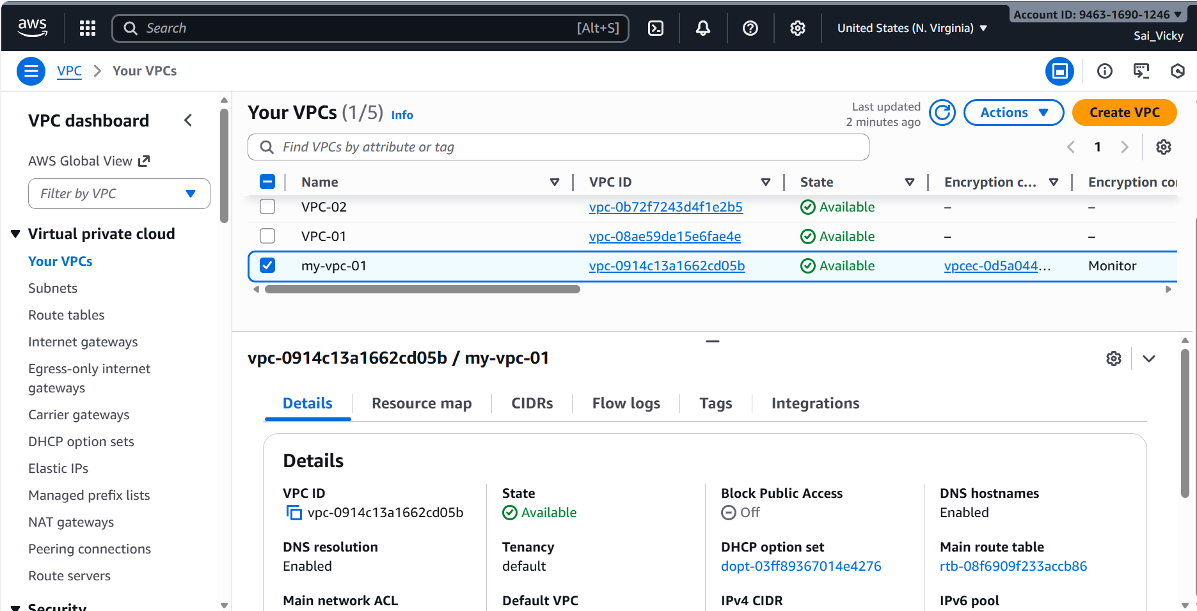

Created 1 Subnet for Public with a range- 198.168.0.0/28 and 1 Subnet for Private with a range- 198.168.0.16/28

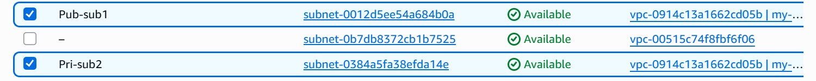

1. **Enable VPC peering for cross-region.**

* In current region- Asia- Hyderabad, launched a instance using the above public subnet created.
* Changed the region to Canada- Central and launched a instance using default VPC and default Subnet.
* Security inbound rules- added a new rule for providing All Traffic.

**Instance launched in Canada-Central**

**VPC set-up complete in Canada region.**

Time to start **peering** both regions **(Asia-Hyderabad and Canada-Central)**

**Steps:**

* **Navigate to VPC**
* **Under VPC, Peering connections**
* **Create Peering connections.**
* **Starting with Asia-Hyderabad**
* **Peering completed at Asia and request sent to Canada**

* **Peering request completed at Canada region by accepting request.**

* **Created a route table and added Internet gateway and Peering connection. The below is Asia-Hyderabad route table.**

* **Created a route table and added Internet gateway and Peering connection. The below is Canada-Central route table.**

**Its time to verify the peering. Starting with Canada-central region Private IP copied and launching the instance from Asia-Hyderabad.**

1. **Enable VPC peering for cross-account (you can collaborate with your friend to do this task).**

* Created a VPC and CIDR range was given as **10.0.1.0/24**
* Navigated to VPC connections
* Added name as – friend-peer
* Selected my **VPC ID**
* Another **Account ID**- Awais
* Another account **region**- N. Virginia
* **VPC**- vpc-06b2a3eecc13beda4
* **VPC peering** request sent to **Awais**

* **Awais** accepted the request

* Navigated to the **route table** and added **Awais CIDR** range VPC and savedthe changes
* Same added my CIDR range in **Awais RT** as well and saved.

* Connect to instance and ping **Awais** security group **-success.**

1. **Set up a VPC Transit Gateway.**

* Created **4 new VPC’s** and provided ranges below.
  + 172.31.0.0/16
  + 10.0.0.0/228
  + 10.0.1.0/28
  + 10.0.2.0/28

* **Created 4 subnets** with a ranges below.
  + 172.31.0.0/16- default
  + 10.0.0.0/28
  + 10.0.1.0/28
  + 10.0.2.0/28

* Created **Transit gateway** and will attach all **VPC’s** to the **gateway** created.

* Created **3 Transit Gateways attachments** and attached **all VPC’s** to it.

* In the below, **Transit gateway route tables,** we have to attach all **VPC ranges.**
* **Transit gateway** attached to all **VPC’s.**

* Launched all **4 instances** using all **4 VPC’s** created and **4 subnets** attached from **VPC’s** created as well.

* Now, we need to attach all **VPC ranges** to the **routing tables** for all 4 **VPC’s with transit gateway.**
* In the below **route table,** we attached the **VPC-01, VPC-02 and VCP-03 CIDR ranges** and added **under Transit Gateway.**

* In the below **route table,** we attached the **VPC-default, VPC-02 and VCP-03 CIDR ranges** and added **under Transit Gateway.**

* In the below **route table,** we attached the **VPC-default, VPC-01 and VCP-03 CIDR ranges** and added **under Transit Gateway.**

* In the below **route table,** we attached the **VPC-default, VPC-01 and VCP-02 CIDR ranges** and added **under Transit Gateway.**

**Now, we need to add Internet gateways and attach all 4 VPC’s.**

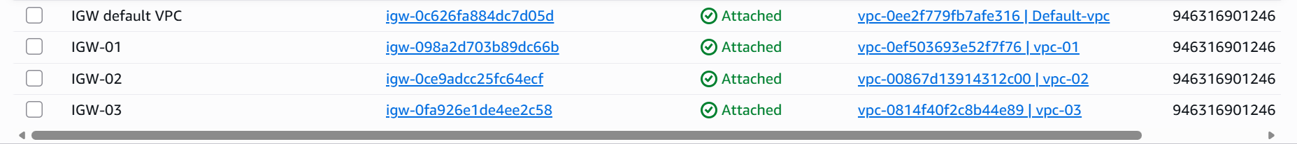

* **Now, we need to attach Internet gateway to the route tables by allowing all traffic.**

* **The final step in ec2 is to add “All Traffic” for all 3 instances and save.**

* **Pinged from vpc-01 to default vpc.**
* **Success.**
* Pinged from default VPC to VPC-01
* Success

* Pinged from VPC-03 to VPC-01
* Success

1. **Set up a VPC Endpoint.**

* Navigate to VPC and create **Endpoint**

* Endpoint will help us to communicate with **AWS without internet services.**
* In filters selected **S3 services** and added **VPC** details.

* In Network settings- selected **my-vpc-01** and enabled **private DNS name.**

* In route table selected private route to communicate without internet.

* **Endpoint** is created now.

* Verified that **private route** has got connected to **my-pri-route** and connections has created **Endpoint-S3**.

